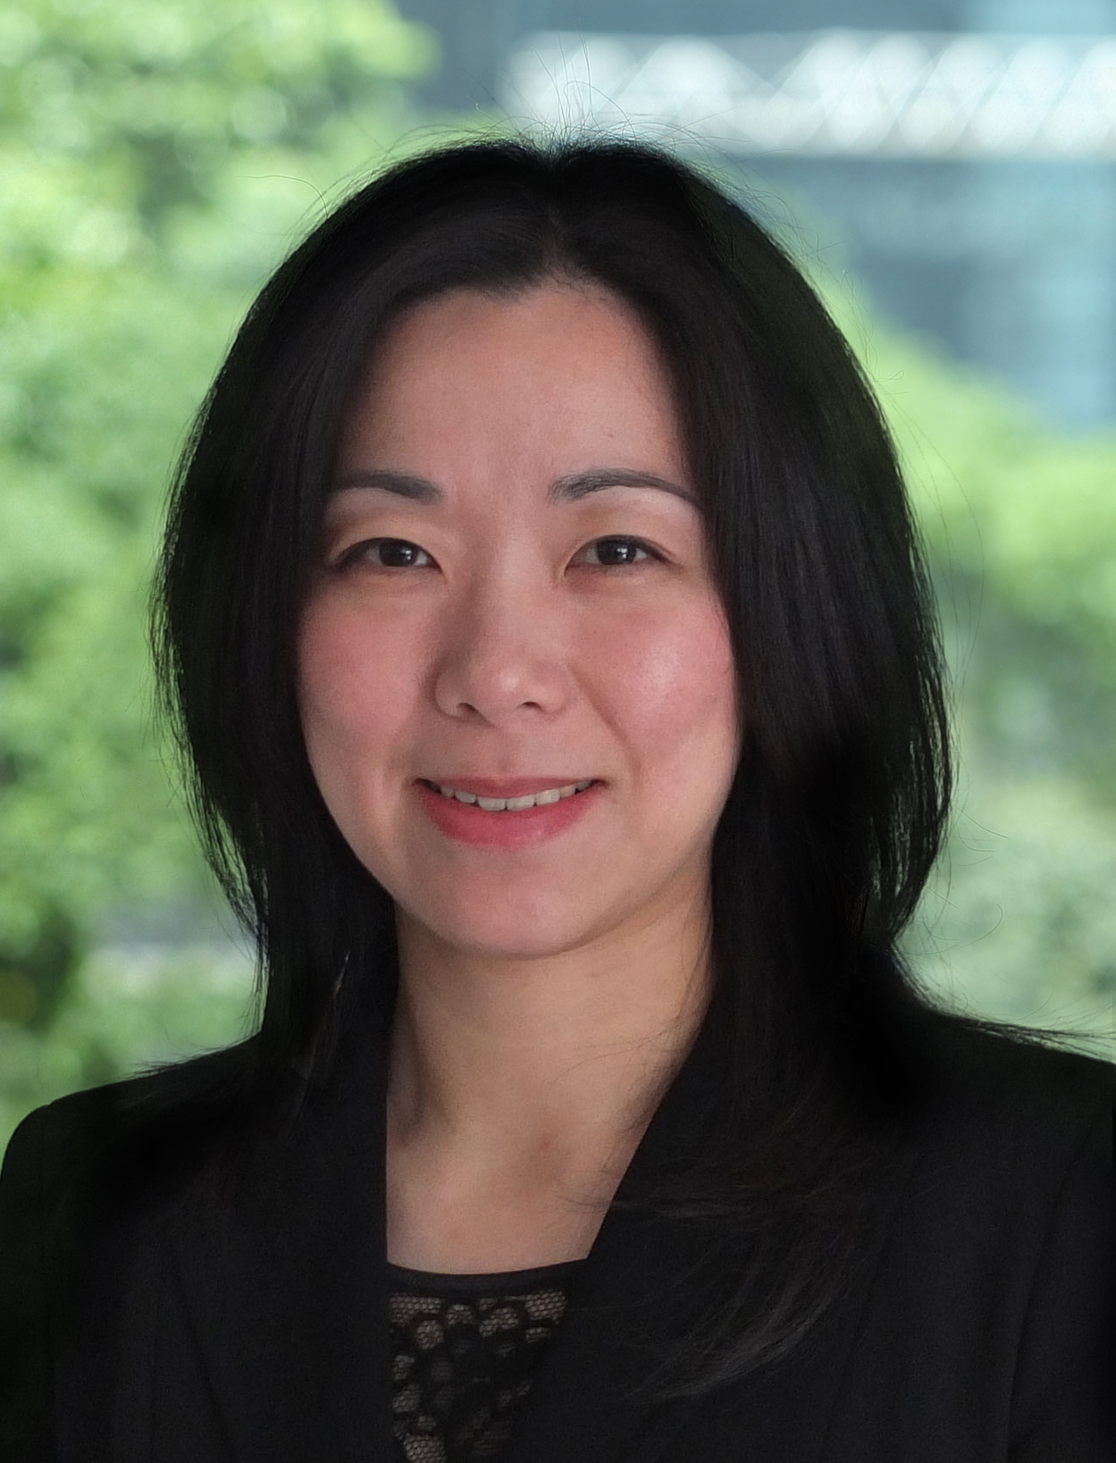  Direct: +852 2248 6091  Tel: +852 2248 6000  catherine.mun@twobirds.com | Catherine Lee Ming MUN 文理明  Catherine is a Partner in the Dispute Resolution Group of Bird & Bird in Hong Kong.  Catherine specialises in commerical and construction-related arbitration and litigation, particularly disputes involving commercial contracts, joint venture contracts, construction contracts, sale of goods and equipment contracts, distributorships, product liability, enforcement of security documents and disputes with cross-border, international and PRC elements.  After qualifying as a solicitor in 1998, Catherine worked in the Litigation Department of Johnson Stokes & Master (now Mayer Brown JSM) with focus on construction disputes and arbitration. She moved on to Baker & McKenzie in 2002 where she worked in the Contruction and International Arbitration Teams of the Dispute Resolution Group. In 2012 she joined Bird & Bird as a partner in the Dispute Resolution Group.  Over the years, Catherine has advised various multi-national entities, stated-owned entities, public sector bodies, international corporations, developers and contractors in relation to issues associated with her practice areas. She has been involved in various kinds of court cases and in more than 50 substantial domestic and international arbitrations including ad hoc arbitrations and institutional HKIAC, CIETAC and ICC arbitrations under various arbitration rules such as HKIAC Domestic Arbitration Rules, UNCITRAL Arbitration Rules, HKIAC Procedures for the Administration of International Arbitration, HKIAC Administered Arbitration Rules, CIETAC Arbitration Rules and ICC Arbitration Rules, as well as ICSID arbitration. Parties involved in arbitrations include those from Mainland China, the US, Europe and the wider Asia Region.  Catherine sits as arbitrator and is on the HKIAC's Panel of Arbitrators, China International Economic and Trade Arbitration Commission's Panel of Arbitrators and Shenzhen Court of International Arbitration (ex-CIETAC's South China Sub-Commission)'s Panel of Arbitrators. She has arbitrated a number of disputes as sole arbitrator or co-arbitrator in HKIAC, CIETAC, ICC and SCIA arbitrations.  Catherine has been materially involved in arbitration industries. She has written publications on arbitration and cross-border related topics and is a co-author of Chitty on Contract: Hong Kong Specific Contracts and of The Hong Kong Arbitration Ordinance: Commentary and Annotations. She was also a part-time law tutor for the Department of Law of the University of Hong Kong.  Catherine also advises commercial clients in pursuing and defending claims in Hong Kong courts as well as in various courts in China. One of the PRC court cases she handled went up to the PRC Supreme People's Court (SPC), and the successful judgment for the client was recognized by the SPC as one of 50 exemplary cases in 2008.  Catherine is currently a committee member of the Hong Kong Law Society (HKLS)'s Arbitration Committee and was a committee member of HKLS's Standing Committee on Compliance (serving a full term of 6 years from 2008).  Catherine is also a Chairman of the Appeal Tribunal under Hong Kong Buildings Ordinance (Cap. 123) and a Member of the Board of Review (Inland Revenue Ordinance).  Her work includes:  - acting for major foreign corporations (including US, Korean, Japanese and European corporations), Hong Kong companies and PRC enterprises in HKIAC, ICC and CIETAC arbitrations and in arbitration-related litigation in the US and in Mainland China;  - acting for government, statutory corporations, property developers, employers and contractors in relation to disputes arising from building and civil engineering projects and professional negligence claims;  - providing advice to investors in international investment disputes against State.  During her practice, Catherine has considered many of the issues which typically arise in:  - international transactions including issues of conflict of laws, forum and construction of contract;  - international arbitrations including jurisdictional and procedural issues;  - construction and civil engineering disputes including claims arising from unforeseeable ground conditions, construction defects, design responsibilities, delays to completion and varied works.  Catherine has also advised and drafted dispute resolution provisions for different kinds of international commercial and corporate contracts where various issues of forum, applicable laws, enforceability of arbitral awards and judgments and methods for dispute resolution are considered.  Professional Affiliations, services and activities related to the legal field  - A Chairman of the Appeal Tribunal under Hong Kong Buildings Ordinance (2012 to 2015).  - Member of the Board of Review (Inland Revenue Ordinance) (1.2015 to 12.2017).  - Committee Member of the Arbitration Committee of Law Society of Hong Kong (2014 to date); Committee Member of the Greater China Legal Affairs Committee (2015); Committee Member of the Standing Committee on Compliance of Law Society of Hong Kong (serving a full term of 6 years - 2008 to 2014).  - Member of Arbitration Committee of International Chamber of Commerce – Hong Kong, China (2012 to date).  - Arbitrator of HKIAC’s Panel of Arbitrators; Arbitrator of CIETAC's Panel of Arbitrators; Arbitrator of Shenzhen Court of International Arbitration (SCIA); Fellow of The Chartered Institute of Arbitrators; Fellow of Hong Kong Institute of Arbitrators.  - Accredited Mediator of Law Society of Hong Kong (to 2013), then Accredited Mediator of HKMAAL Panel of Mediators; Mediator of Land (Compulsory Sale for Redevelopment) Ordinance Pilot Mediation Scheme’s List of Mediators.  - Part-time tutor on Law of Contract for Department of Law, University of Hong Kong (2013-2014).  - Involved in assisting with the International Arbitration and Dispute Settlement Program of the School of Law of Tsinghua University (2014).  - Served as an arbitrator at the annual Willem C. Vis Moot (East) International Commercial Arbitration Moot Competition (2005 to 2015).  - Served as an arbitrator at the inaugural International ADR Mooting Competition in 2010 conducted by City University of Hong Kong in association with the CIETAC and Columbia University (New York) and later in 2011 to 2014.  - Serving as a judge at The 12th Red Cross International Humanitarian Law (IHL) Moot (2013-15).  - Alumni Mentor of Law Faculty, University of Hong Kong (2007-09, 2010-14); Alumni Mentor of Business and Economic Association, University of Hong Kong (2010-12).  Seminars and Talks  - Giving various seminars to clients and external seminars on arbitration and construction issues to various professional institutes and organizations, such as Hong Kong Institute of Surveyors, Chartered Institution of Civil Engineering Surveyors, the Hong Kong Institute of Architects, Joint Mediation Helpline Office Limited (JMHO), City University, Hong Kong University, HKIAC and Chartered Institute of Arbitrators.  - Seminar to Beijing Arbitration Commission on construction arbitration (2008).  - Speaker at a London conference on “Issues Relating to Enforcement in International Arbitration” (with the session concerned chaired by Professor Sir Roy Goode) in 2008.  - Speaker at Vis Moot’s “Generations in Arbitration Workshop on The Effectiveness of Damages or Other Remedies to promote Efficiency” in 2010.  - Speaker at B&M’s External Seminar on Annual Property Update - Updates on Arbitration Issues in December 2010.  - Speaker at three Workshops and seminars on Compulsory Sale for Redevelopment Ordinance (Cap 545) organised by Joint Mediation Helpline Office (“JMHO” – jointly formed by Hong Kong Mediation Council, the Hong Kong Bar Association, the Law Society of Hong Kong, the Chartered Institute of Arbitrators (East Asia Branch), the Hong Kong Institute of Arbitrators, the Hong Kong Institute of Architects, the Hong Kong Institute of Surveyors and the Hong Kong Mediation Centre) on 15 January 2011, 5 March 2011 and 4 April 2011.  - Speaker at a seminar organised by HKIAC and Hong Kong University on “Practice of International Arbitration in Asia Pacific” (2011).  - With Teresa Cheng S.C. organizing and presenting at consultation meetings on New Dispute Resolution Mechanism in Construction Contracts in 2012.  - Speaker at a talk to The Chartered Institute of Arbitrators on "Enforcement of Arbitral Awards" in 2013.  - Speaker at HK45 Arbitration Update for 2014, along with other speakers from Korea, India and Singapore (2014).  - Speaker at a 2-day Seminar "Construction Contract Essentials 2014" organized by HKU's Centre for Infrastructure & Construction Industry Development and HK Legal Training Institute (2014).  - Speaker at the Ninth Annual Generations in Arbitration Conference (GIA Conference) – "The Evolving Face of International Arbitration: from the East to the West" held on 14 March 2015.  - Speaker at a talk to The Chartered Institute of Arbitrators on "Arbitration is a long and costly process. Is it true?" in 2015.  Published Articles and Books  - Co-author of a chapter on arbitration agreements in Chitty on Contracts, Hong Kong Specific Contracts.  - Co-contributor to The Hong Kong Arbitration Ordinance: Commentary and Annotations, Sweet & Maxwell.  - Co-author to Lexis Practical Guidance on Dispute Resolution and Lexis DR Tracker.  - Co-author of a chapter on Cross-Border Arbitration in the book China Briefing’s Business Guide to Greater Pearl River.  - Co-author of a chapter on Construction Arbitration in the book Arbitration in China: A Practical Guide, Sweet & Maxwell Asia.  - Articles in Asian Dispute Review – Awards and Challenges to Awards – Part I & Part II published( April & July 2014); Judicial Review of Tunnel Toll Arbitration (January 2006).  - Co-author to an article China Deals with LCD panel suppliers' anti-competitive behavior (June 2013) published on Lexology in cooperation with Association of Corporate Counsel.  - Contributor to the chapters on Hong Kong and China in Baker & McKenzie International Arbitration Yearbook: 2010-2011.  - Co-author to an article New Arrangement to Enforce Hong Kong Judgments in China (September 2006) published in Asialaw.  Education & Bar Admission  2009 Postgraduate Diploma in International Commercial Arbitration, Queen Mary, University of London, Distinction.  2008 Second LL.B (on PRC law), Tsinghua University, Distinction on thesis.  2005 Certificate in PRC Civil and Commercial Law, Tsinghua University and University of Hong Kong.  2000 Admitted as a Solicitor of the High Court of England and Wales.  1998 Admitted as a Solicitor of the High Court of the HKSAR.  1996 Bachelor of Civil Law, St Catherine’s College, University of Oxford.  1995 Postgraduate Certificate in Laws, University of Hong Kong, Distinction.  1994 LL.B, University of Hong Kong, 1st Class Hons.  Work Experience  Feb 2012 to date Bird & Bird, Partner  Jul 2002 – Baker & McKenzie, Special Counsel/Senior Associate/  10 Feb 2012 Associate  Aug 1996 – Johnson Stokes & Master, now Mayer Brown JSM,  Jul 2002 Associate / Trainee Solicitor  Languages  English, Cantonese, Mandarin.

